FACULTY EVALUATION
Programme Name: SEP Scale Masterclass Module 2 Tanzania (25th May 2026 - 29th May 2026)
Session: Review (identify gaps/challenges) your business plan from module 1 || Decide key issues for long-term sustainability || Identify areas where support is needed
Faculty Name: Dr. Isaac Muiruri Gachanja
No. of Respondents: 18
No. of Participants: 18
Evaluation Parameter | (%) Individual Score | (%) Programme Average
Punctuality (Commencement and Completion of Sessions) | 92 | 95
How well do you understand the core concepts presented? | 91 | 90
Rate your confidence in applying the new skills learnt | 83 | 87
Degree of Faculty preparedness for the sessions | 92 | 92
Content and methodology of the program | 88 | 90
Quality of class and group discussions | 92 | 90
The information presented in the course is relevant to my work (ministry) | 89 | 90
Average scores | 90 | 91

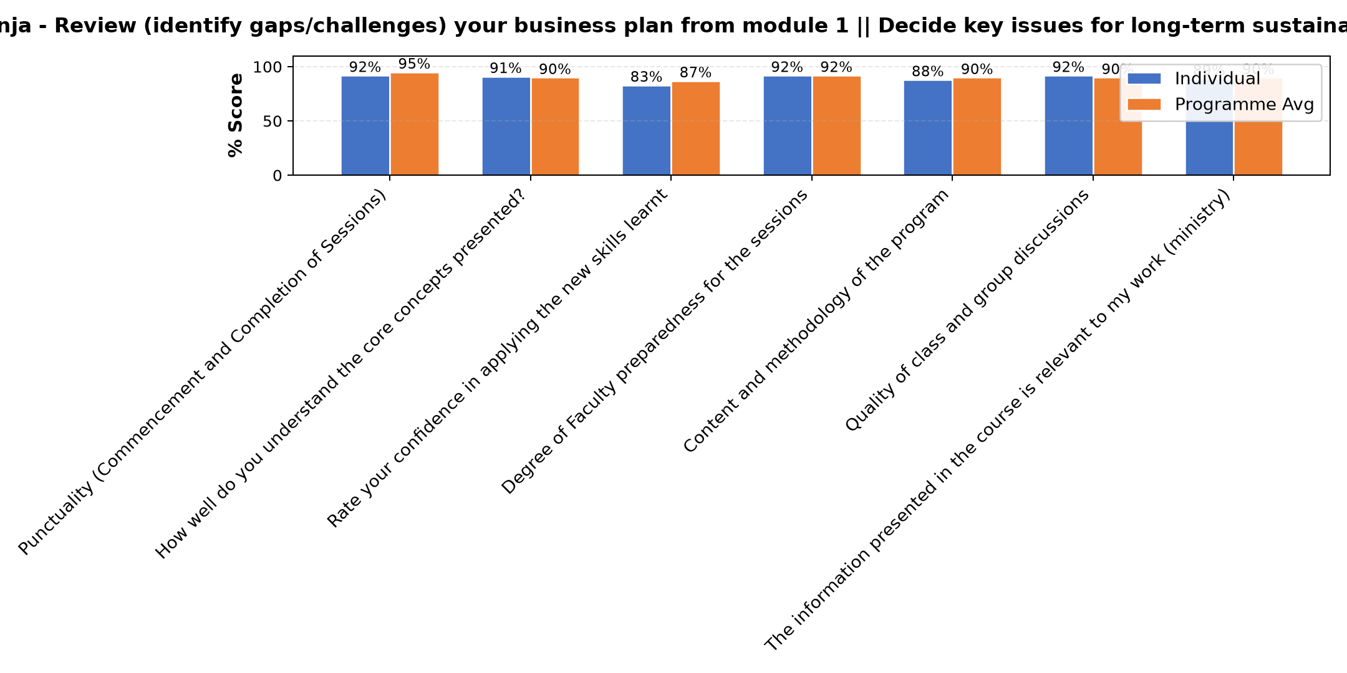

Comments & Feedback
- • Network
- • Some barriers that might prevent me from applying what I learned, lack of enough resources and financial support, and balancing work responsibilities with implementing new ideas. Another challenge may be resistance to change from people around me or difficulty in accessing continuous mentorship and support. However, with commitment, teamwork, and proper planning, I believe these challenges can be overcome.
- • Economic hardship
- • Enough capital
- • Excellent
- • No
- • Funds
- • The berriers which can prevente me from what I have learnt is just insufficient of capital to make our social interprise atractive to our customers
- • Nothing
- • I hope that there will be no barriers, may be from our fellow workers in the daily activities.If this happens we will look for good ways to perform our work.
- • If the congregation will allocate me to work in area which is irrelevant to what I have learned.
- • Invironmental competition
- • Customers delay their payments.
SUBMITTED THROUGH:
SBS Evaluation Automation System

